[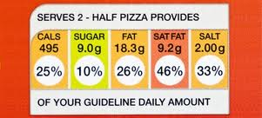](http://www.google.co.uk/imgres?q=food+labels&num=10&hl=en&sa=X&biw=1024&bih=584&tbm=isch&tbnid=GH7ByLJgbf8HKM:&imgrefurl=http://www.nhs.uk/Livewell/Goodfood/Pages/food-labelling.aspx&docid=04G1S3tu1cXJYM&imgurl=http://www.nhs.uk/Livewell/Goodfood/PublishingImages/front_label_colour_377.jpg&w=377&h=171&ei=59OXUNLmD4PO0QWnxYGIBQ&zoom=1&iact=hc&vpx=337&vpy=225&dur=500&hovh=136&hovw=301&tx=168&ty=88&sig=111293813288622565442&page=1&tbnh=98&tbnw=216&start=0&ndsp=10&ved=1t:429,r:1,s:0,i:140)

[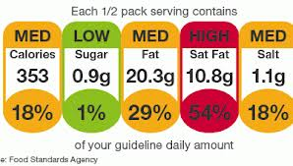](http://www.google.co.uk/imgres?q=food+labels&start=309&num=10&hl=en&biw=1024&bih=584&tbm=isch&tbnid=RKGupX2Aaw79iM:&imgrefurl=http://phenomenalhealthstyle.tv/2012/10/25/is-misreading-food-labels-stopping-you-from-losing-weight/&docid=qFLkAswpO_G6iM&imgurl=http://phenomenalhealthstyle.tv/files/2012/10/63685888_food_labels_464-400x227.gif&w=400&h=227&ei=PNeXUJCWMoaR0AW78IDQBg&zoom=1&iact=hc&vpx=508&vpy=102&dur=312&hovh=169&hovw=298&tx=118&ty=95&sig=111293813288622565442&page=14&tbnh=90&tbnw=159&ndsp=24&ved=1t:429,r:21,s:309,i:146)

[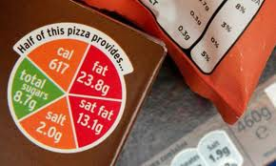](http://www.google.co.uk/imgres?q=food+labels&start=189&num=10&hl=en&biw=1024&bih=584&tbm=isch&tbnid=SzO0YmHa5GR77M:&imgrefurl=http://www.guardian.co.uk/commentisfree/poll/2012/oct/24/traffic-light-labelling-food-nutrition-useful&docid=S4cI6DWlLDBb-M&imgurl=http://static.guim.co.uk/sys-images/Society/Pix/pictures/2008/09/29/1label.jpg&w=460&h=276&ei=99aXUJGbHKeM0AXcyIGoCA&zoom=1&iact=hc&vpx=220&vpy=251&dur=1437&hovh=174&hovw=290&tx=163&ty=114&sig=111293813288622565442&page=9&tbnh=92&tbnw=154&ndsp=26&ved=1t:429,r:20,s:189,i:69)[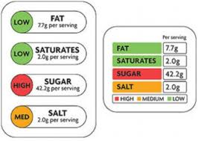](http://www.google.co.uk/imgres?q=food+labels&num=10&hl=en&biw=1024&bih=584&tbm=isch&tbnid=6DAX4JbK_W-VdM:&imgrefurl=http://www.internationalsupermarketnews.com/news/770&docid=9I67G-6PgcQh3M&imgurl=http://www.internationalsupermarketnews.com/wp-content/uploads/2011/03/Food-labels.jpg&w=468&h=333&ei=09OXUMz4MeW10QWNsoDYDQ&zoom=1&iact=hc&vpx=227&vpy=166&dur=1765&hovh=189&hovw=266&tx=109&ty=110&sig=111293813288622565442&page=2&tbnh=102&tbnw=143&start=10&ndsp=24&ved=1t:429,r:19,s:10,i:171)[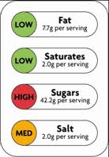](http://www.google.co.uk/imgres?q=food+labels&num=10&hl=en&sa=X&biw=1024&bih=584&tbm=isch&tbnid=Y6skRli2WPZGrM:&imgrefurl=http://www.qub.ac.uk/elearning/public/HealthyEating/FoodLabellingandGDAs/&docid=ZZLa_Qa7whJ6xM&imgurl=http://www.qub.ac.uk/elearning/media/Media,217913,en.png&w=173&h=248&ei=59OXUNLmD4PO0QWnxYGIBQ&zoom=1&iact=hc&vpx=818&vpy=251&dur=2484&hovh=198&hovw=138&tx=74&ty=139&sig=111293813288622565442&page=3&tbnh=119&tbnw=83&start=34&ndsp=28&ved=1t:429,r:19,s:34,i:311)[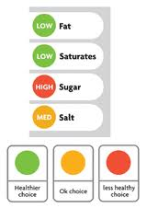](http://www.google.co.uk/imgres?q=food+labels&num=10&hl=en&sa=X&biw=1024&bih=584&tbm=isch&tbnid=lKnPowBeh4Hd1M:&imgrefurl=http://www.diabetes.org.uk/Information-for-parents/Food/Understanding-labels/&docid=l5FaXtZ70VDL5M&imgurl=http://www.diabetes.org.uk/upload/info%252520for%252520parents%252520carers/traffic-light-food-label_20.gif&w=200&h=283&ei=59OXUNLmD4PO0QWnxYGIBQ&zoom=1&iact=hc&vpx=104&vpy=223&dur=1719&hovh=226&hovw=160&tx=97&ty=102&sig=111293813288622565442&page=3&tbnh=130&tbnw=92&start=34&ndsp=28&ved=1t:429,r:0,s:34,i:252)[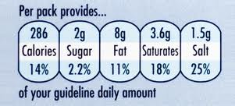](http://www.google.co.uk/imgres?q=food+labels&num=10&hl=en&sa=X&biw=1024&bih=584&tbm=isch&tbnid=AuYyNKHSMASgBM:&imgrefurl=http://www.nhs.uk/Livewell/Goodfood/Pages/food-labelling.aspx&docid=04G1S3tu1cXJYM&imgurl=http://www.nhs.uk/Livewell/Goodfood/PublishingImages/front_pack_label2_377.jpg&w=377&h=171&ei=59OXUNLmD4PO0QWnxYGIBQ&zoom=1&iact=hc&vpx=102&vpy=220&dur=500&hovh=136&hovw=301&tx=156&ty=63&sig=111293813288622565442&page=1&tbnh=104&tbnw=229&start=0&ndsp=10&ved=1t:429,r:0,s:0,i:137)

[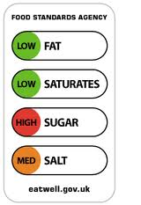](http://www.google.co.uk/imgres?q=food+labels&num=10&hl=en&biw=1024&bih=584&tbm=isch&tbnid=9qc-dnOQdB7OXM:&imgrefurl=http://www.emstudenthub.com/diet-nutrition/guide-to-food-labelling/&docid=rmngwrUWjZN3LM&imgurl=http://www.emstudenthub.com/wp-content/uploads/2010/10/food-label-graphic2.png&w=201&h=292&ei=09OXUMz4MeW10QWNsoDYDQ&zoom=1&iact=hc&vpx=643&vpy=120&dur=547&hovh=233&hovw=160&tx=88&ty=109&sig=111293813288622565442&page=2&tbnh=135&tbnw=93&start=10&ndsp=24&ved=1t:429,r:16,s:10,i:161)

[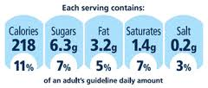](http://www.google.co.uk/imgres?q=food+labels&start=239&num=10&hl=en&biw=1024&bih=584&tbm=isch&tbnid=JENz6WjK8TTPVM:&imgrefurl=http://blog.derbyfitness.co.uk/understanding-food-labels/&docid=6wPKlGBMBA1E1M&imgurl=http://blog.derbyfitness.co.uk/wp-content/uploads/2011/06/GDA.gif&w=300&h=128&ei=99aXUJGbHKeM0AXcyIGoCA&zoom=1&iact=hc&vpx=615&vpy=29&dur=4734&hovh=102&hovw=240&tx=136&ty=79&sig=111293813288622565442&page=11&tbnh=65&tbnw=153&ndsp=24&ved=1t:429,r:22,s:239,i:235)

[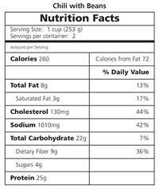](http://www.google.co.uk/imgres?q=food+labels&num=10&hl=en&biw=1024&bih=584&tbm=isch&tbnid=afmyHUEI0MxLIM:&imgrefurl=http://dietforhumans.com/2011/06/05/where-do-calorie-numbers-on-food-labels-come-from/&docid=DhYU2JprwmlDzM&imgurl=http://dietforhumans.com/wp-content/uploads/2011/06/callabel.jpg&w=250&h=297&ei=09OXUMz4MeW10QWNsoDYDQ&zoom=1&iact=hc&vpx=414&vpy=212&dur=985&hovh=237&hovw=200&tx=102&ty=167&sig=111293813288622565442&page=1&tbnh=173&tbnw=146&start=0&ndsp=10&ved=1t:429,r:7,s:0,i:95)

[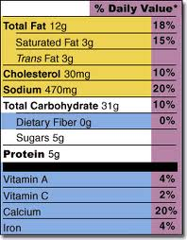](http://www.google.co.uk/imgres?q=food+labels&num=10&hl=en&biw=1024&bih=584&tbm=isch&tbnid=ebKX8eMYj_CDqM:&imgrefurl=http://www.fda.gov/Food/ResourcesForYou/Consumers/NFLPM/ucm274593.htm&docid=Xv0kw9BX0FV7PM&imgurl=http://www.fda.gov/ucm/groups/fdagov-public/documents/image/ucm079016.gif&w=257&h=330&ei=09OXUMz4MeW10QWNsoDYDQ&zoom=1&iact=hc&vpx=316&vpy=178&dur=2578&hovh=254&hovw=198&tx=86&ty=181&sig=111293813288622565442&page=2&tbnh=128&tbnw=100&start=10&ndsp=24&ved=1t:429,r:8,s:10,i:136)